Chapter 16, Problem 80.

Refer to the network in Fig. 16.98. Find the following transfer functions:

- H₁(s) = V_{o}(s)/V_{s}(s)
- H₂(s) = V_{o}(s)/I_{s}(s)
- H₃(s) = I_{o}(s)/I_{s}(s)
- H₄(s) = I_{o}(s)/V_{s}(s)

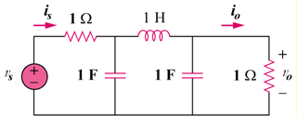

Figure 16.98
For Prob. 16.80.

